MANAV RACHNA INTERNATIONAL INSTITUTE OF RESEARCH AND STUDIES

School of Computer Applications

COURSE NAME: Web Technologies (4.5CA152C01)

ASSIGNMENT: I

Q1. Construct the following HTML page using different HTML tags.

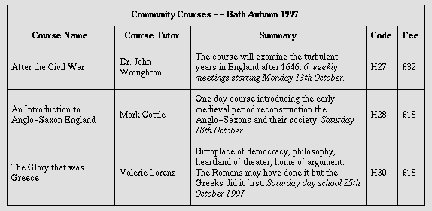

Code:

<!DOCTYPE html>
<html lang="en">
<head>
<meta charset="UTF-8">
<meta name="viewport" content="width=device-width, initial-scale=1.0">
<title>Community Courses -- Bath Autumn 1997</title>
</head>
<body>

<h2 style="text-align: center;">Community Courses -- Bath Autumn 1997</h2>

<table border="1" cellpadding="5" cellspacing="0" width="100%">
<tr>
<th>Course Name</th>
<th>Course Tutor</th>
<th>Summary</th>
<th>Code</th>
<th>Fee</th>
</tr>
<tr>
<td>After the Civil War</td>
<td>Dr. John Wroughton</td>
<td>The course will examine the turbulent years in England after 1646. 6 weekly meetings starting Monday 13th October.</td>
<td>H27</td>
<td>£32</td>
</tr>
<tr>
<td>An Introduction to Anglo-Saxon England</td>
<td>Mark Cottle</td>
<td>One day course introducing the early medieval period reconstruction the Anglo-Saxons and their society. Saturday 18th October. </td>
<td>H28</td>
<td>£18</td>
</tr>
<tr>
<td>The Glory that was Greece</td>
<td>Valerie Lorenz</td>
<td>Birthplace of democracy, philosophy, heartland of theater, home of argument. The Romans may have done it but the Greeks did it first. Saturday day school 25th October 1997. </td>
<td>H30</td>
<td>£18</td>
</tr>
</table>

</body>
</html>

Output:

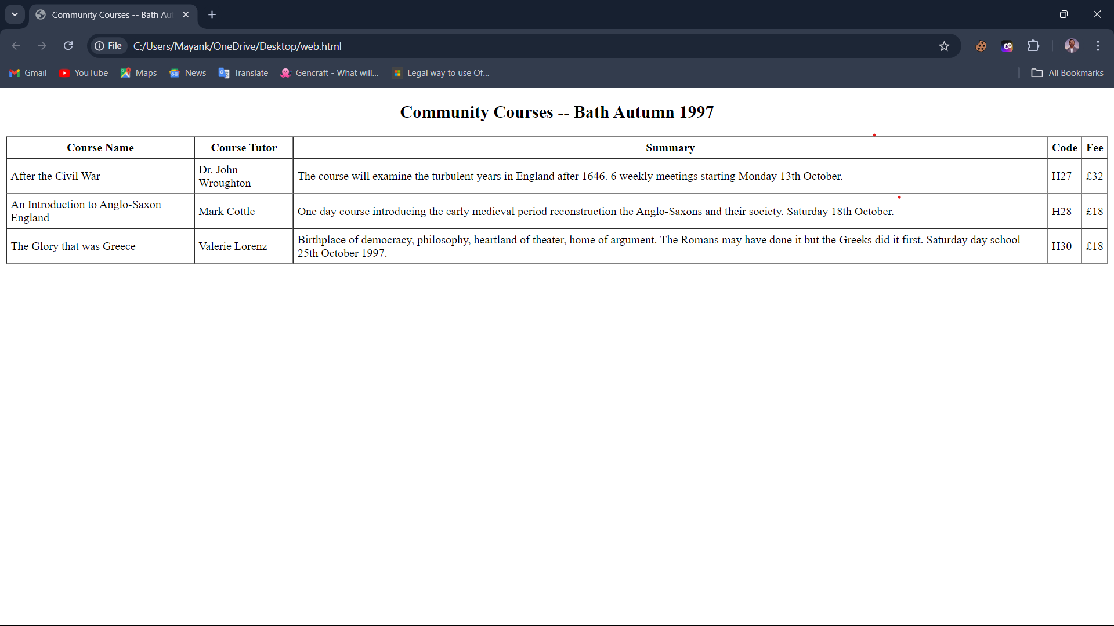

Q2. Elaborate hyperlink? How is it used in HTML to enhance the working and connectivity? Explain the different types of hyperlinks in detail.

What is a Hyperlink?
A hyperlink (or simply a link) is a reference or navigation element in HTML that allows users to jump from one location (page, section, document) to another. It's one of the foundational features of the World Wide Web, enabling users to explore related content easily by clicking or tapping on a link

How Hyperlinks are Used in HTML?
In HTML, hyperlinks are created using the <a> (anchor) tag. The href (Hypertext REFerence) attribute defines the destination (URL) of the link. Hyperlinks help to connect various pages or sections of a website, navigate users to different websites, and download resources like files.

Basic Syntax of a Hyperlink:

<a href=”URl”> Link Text <a/>

Hyperlinks are used for enhance working and connectivity by Navigation, Connectivity, Cross-Referencing, User Experience.

HTML Links - The target Attribute
By default, the linked page will be displayed in the current browser window. To change this, you must specify another target for the link.
The target attribute specifies where to open the linked document.
The target attribute can have one of the following values:
- _self - Default. Opens the document in the same window/tab as it was clicked
- _blank - Opens the document in a new window or tab
- _parent - Opens the document in the parent frame
- _top - Opens the document in the full body of the window

Types of Hyperlinks in HTML
- Text Hyperlinks:

The most common type of hyperlink, where a piece of text acts as the clickable link.

<a href="https://www.google.com">Google</a>

When users click on the text "Google", it will take them to the URL specified.

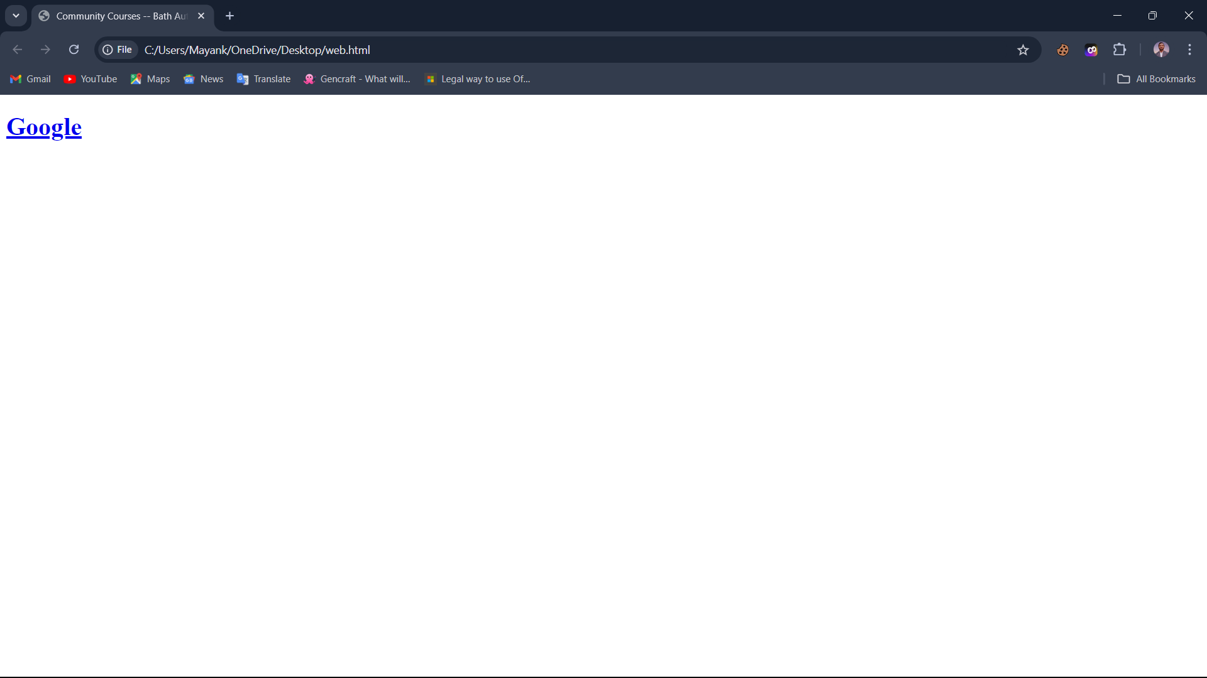

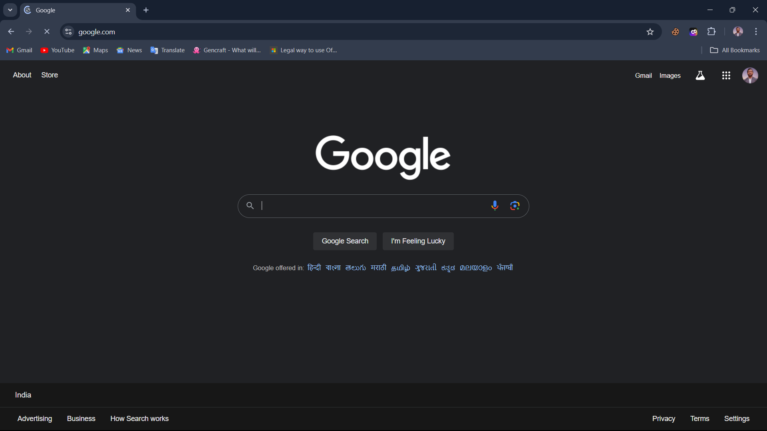

2. Image Hyperlinks:
Images can also be used as clickable links. This is useful for banners, logos, or buttons that lead to another page.
<a href="https://www.example.com"><img src="logo.png" alt="Example Logo"> </a>
Images can also be used as clickable links. This is useful for banners, logos, or buttons that lead to another page.

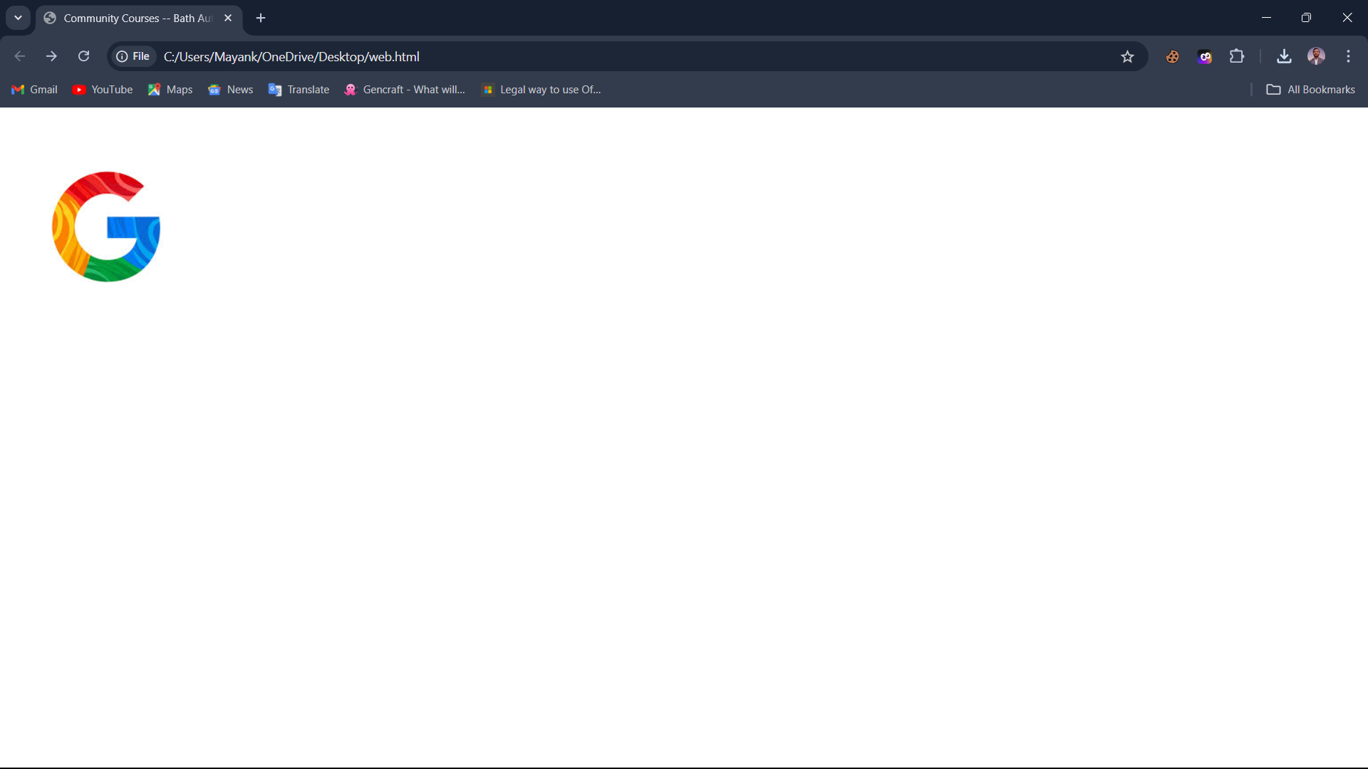

3. Email Hyperlinks:
Links that automatically open the user's default email client and begin composing an email to a predefined address.
<a href="mailto:mayankaggarwal9654@gmail.com">Email Us</a>
Clicking this will open the email app with the "To" field filled with "someone@example.com".
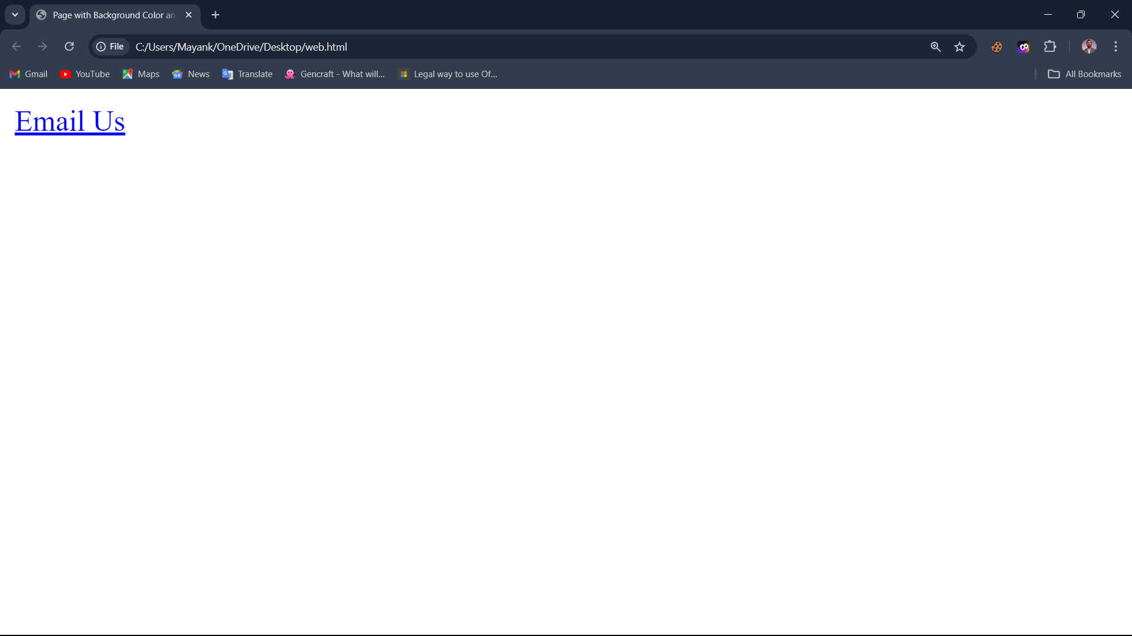
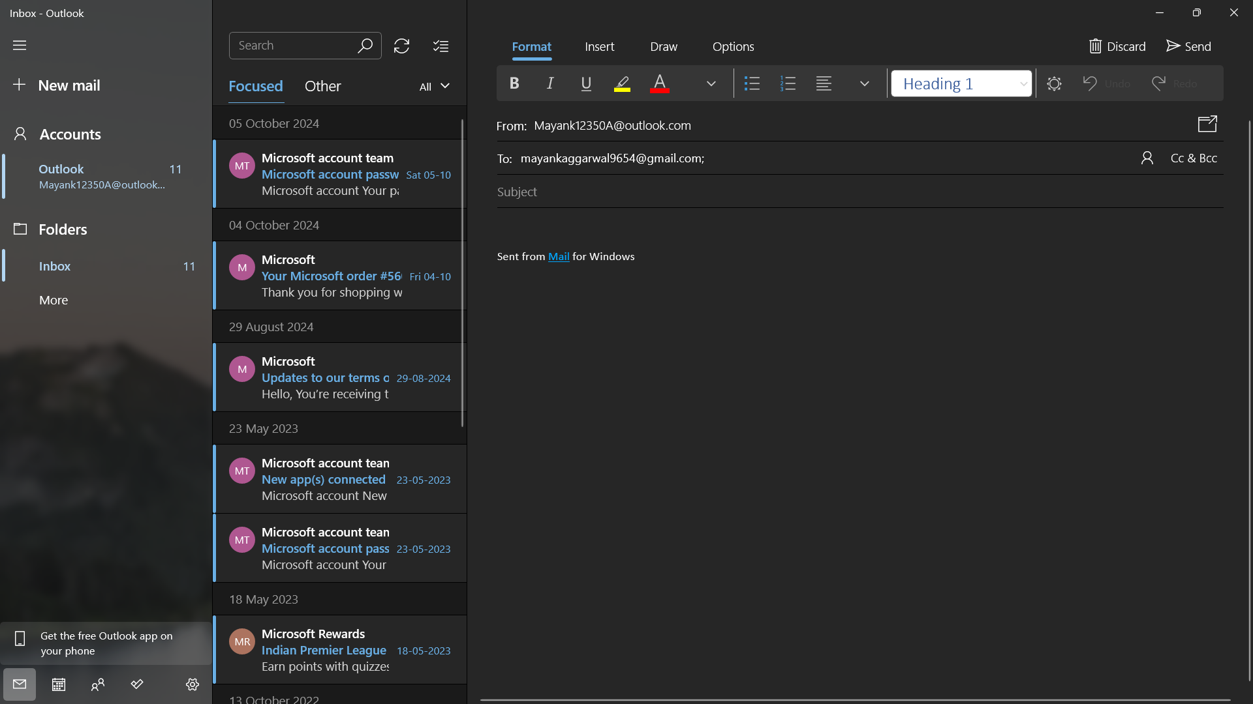

4. Anchor Links (Internal Links):
These links help the user navigate to different sections within the same webpage or a specific section of another page. Anchors are identified by the id attribute.
<a href="about.html#section2">Go to Section 2 on About Page</a>
Clicking this will take the user to a specific section on another webpage (in this case, about.html).
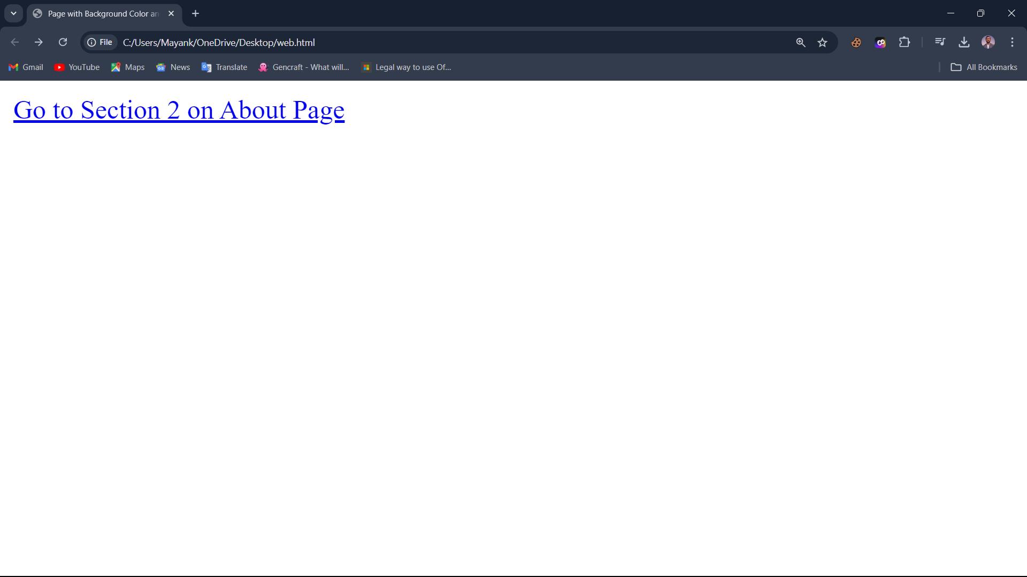



5. Absolute URLs
Absolute URLs are ideal when linking to a different website or to a resource hosted on a different domain or subdomain.

<a href="https://www.google.com/">Google</a>

6. Relative URLs

Relative URLs are ideal when linking to pages or resources within the same website.
<a href="/about.html">About Us</a>

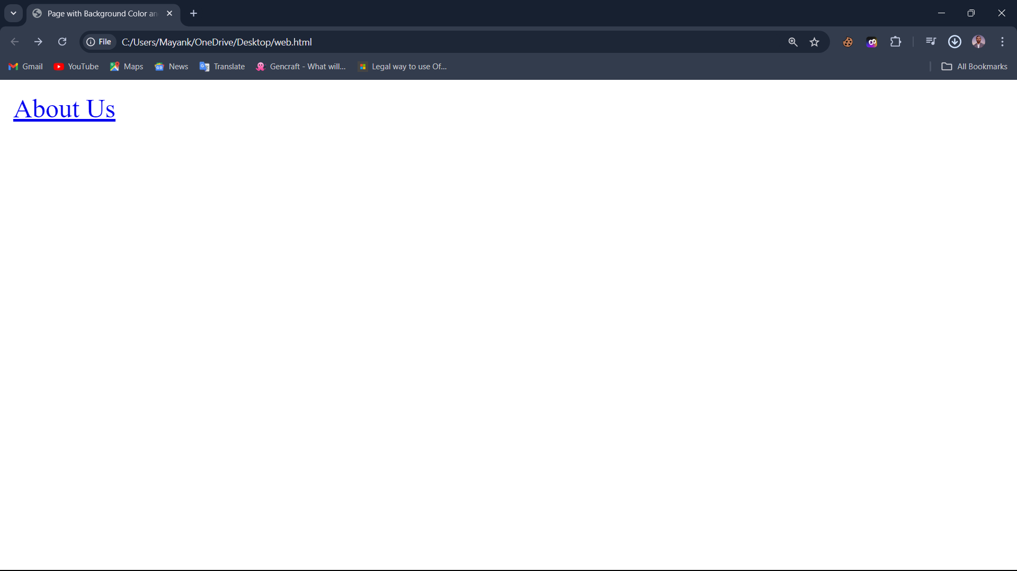



Q3 Change the background color of the page. At the bottom create a link to take the user to the top of the page and vice versa

Code:

<!DOCTYPE html>
<html lang="en">
<head>
<meta charset="UTF-8">
<meta name="viewport" content="width=device-width, initial-scale=1.0">
<title>Scroll to Top/Bottom</title>
</head>
<body style="background-color: lightblue;">
<a href="#bottom">Go to Bottom</a>

<h1>Welcome!</h1>
<p>This is an example of scrolling between the top and bottom of a page.</p>

<div style="height: 1000px;"></div>

<h2 id="bottom">You are at the bottom!</h2>
<a href="#top">Go to Top</a>
</body>
</html>

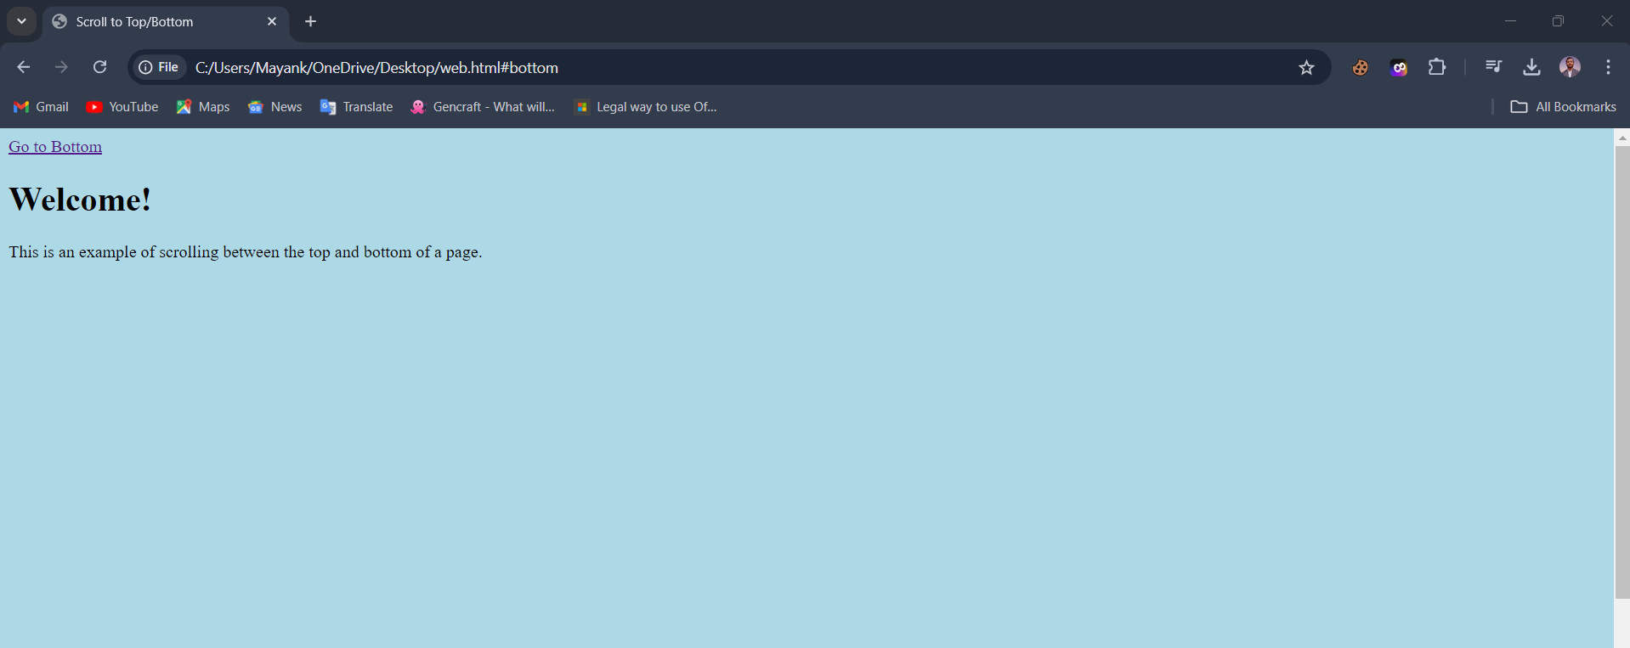

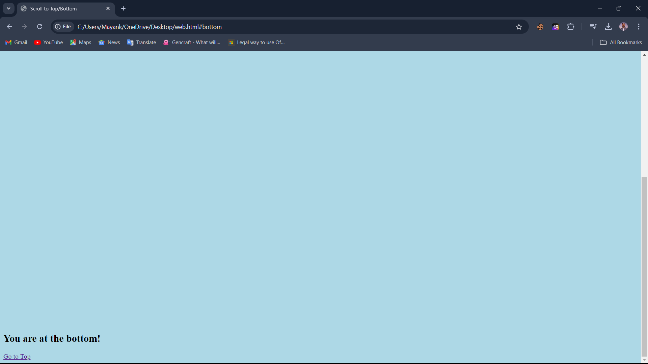

Q4. Compare different tags used in the HTML table while creating any web page.

Tag | Purpose
<table> | Defines the table
<tr> | Defines a row
<th> | Defines a header cell
<td> | Defines a data cell
<caption> | Adds a title to the table
<thead> | Groups header rows
<tbody> | Groups the body content
<tfoot> | Groups footer rows (e.g., totals)

<!DOCTYPE html>
<html lang="en">
<head>
<meta charset="UTF-8">
<meta name="viewport" content="width=device-width, initial-scale=1.0">
<title>Scroll to Top/Bottom</title>
</head>
<body>

<table border="1">
<caption>Sales Report</caption>

<thead>
<tr>
<th>Product</th>
<th>Sales</th>
</tr>
</thead>

<tbody>
<tr>
<td>Product A</td>
<td>50</td>
</tr>
<tr>
<td>Product B</td>
<td>30</td>
</tr>
</tbody>

<tfoot>
<tr>
<td>Total</td>
<td>80</td>
</tr>
</tfoot>
</table>

</body>
</html>

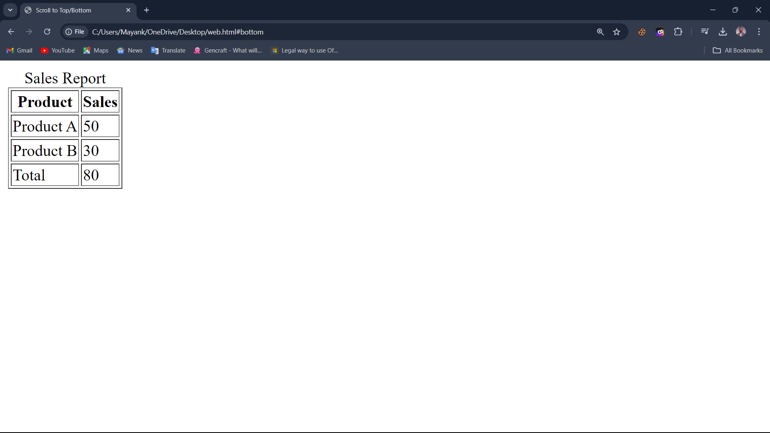

Q5. Make up a table of data. Your table must have at least four rows and four Columns. It must have at least one Rowspan and one Colspan specifier.
(And yes, the attribute's value must be greater than one!)

Code:

<!DOCTYPE html>
<html lang="en">
<head>
<meta charset="UTF-8">
<meta name="viewport" content="width=device-width, initial-scale=1.0">
<title>Class Schedule</title>
</head>
<body>
<table border="1">
<caption>Class Schedule</caption>
<thead>
<tr>
<th>Time</th>
<th>Monday</th>
<th>Tuesday</th>
<th>Wednesday</th>
</tr>
</thead>
<tbody>
<tr>
<td>9:00 - 10:00</td>
<td>Math</td>
<td>English</td>
<td>History</td>
</tr>
<tr>
<td>10:00 - 11:00</td>
<td colspan="2">Science</td> <!-- colspan used here -->
<td>Art</td>
</tr>
<tr>
<td>11:00 - 12:00</td>
<td rowspan="2">Physical Education</td> <!-- rowspan used here -->
<td>Music</td>
<td>Geography</td>
</tr>
<tr>
<td>12:00 - 1:00</td>
<td>Computer Science</td>
<td>Drama</td>
</tr>
</tbody>
</table>
</body>
</html>

Output:

